Fire Emblem: Multiplayer

### Instructions Manual

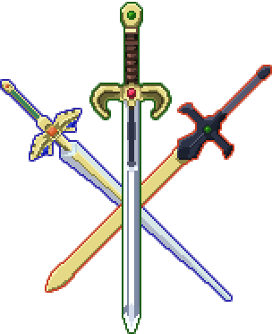

Original project by Shawn “chudooder” Wu and Young “jedyobidan” Wang

## Controls (configurable in app.config)

* Z to select
* X to cancel
* Up/Down/Left/Right to move the cursor
* Mouse/Keyboard control when in the lobby and connection screen
* Other controls will be displayed on screen

## Getting Started

Fire Emblem: Multiplayer is an online, multiplayer tactical experience in which you fight your friends with your favorite characters from the Fire Emblem games. You will need to run a server and multiple clients to play this game.

Instructions for server computer (only one needed):

1. Make sure the server computer port forwards on port **21255** (this is the port Fire Emblem: Multiplayer uses).
2. Run FEServer.jar
3. Select options for the game.
   1. **Map**: the map the game will be played on.
   2. **Objective**: the victory conditions of the game. Examples include “Rout the Enemy,” and “Seize.” Some maps may not support certain objectives.
   3. **Max** **Units**: the maximum number of units each player may have.
   4. **Pick Mode**: set whether you will allow any picks or drafting (see Draft Mode)
   5. **Modifiers**: Craaaaazy stuff. Throw common sense out the window and put in special conditions to fight under. Hover over the modifiers to find out what they do.
4. Click on “Start Server”
5. The server will display its local IP address. If you are playing over LAN (i.e. connected to the same network), use this IP. Otherwise you will need to find your public IP. <http://www.whatismyip.com/>
6. If you are playing as well, refer to “Instructions for Client Computers” as well.

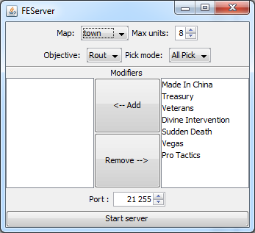

#### Getting Started (cont.)

Instructions for client computers (one for each player):

1. Run Fire Emblem Multiplayer.jar
2. Once the game loads, you will be brought to the title screen. Press the Enter key to start.
3. You will be brought to the **connection screen.** From here, you may build a team (refer to “Building a Team”) or join the lobby.
4. To join the lobby, enter your name and the IP of the FEServer. If you are playing over LAN, enter the IP as shown on the FEServer Application (refer to “Instructions for server computer”). Otherwise enter the public IP of the FEServer. If the server uses a port different from 21255, it needs to be specified by suffixing the IP with a colon and the port number (ex: 192.168.0.5:12345)
   1. *Tip: If you are running the FEServer on the same computer as the client, you may enter “localhost” as the server’s IP Address. The port still has to be specified unless it is the default.*
5. You will be brought to the **lobby**. From here you can chat, spectate the game, or join a team. (refer to “Lobby Screen” for further instructions).

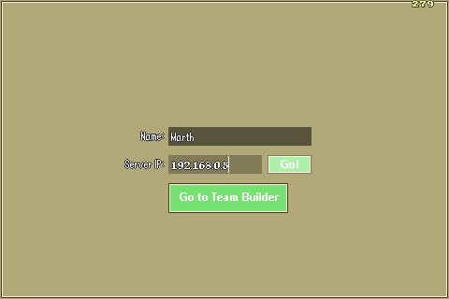

## The Lobby Screen

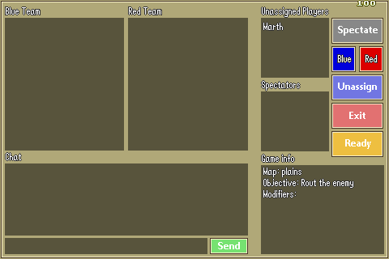

**Spectate:** Spectate the game. You will be able to see all the action, but you will not have an army of your own.

**Blue/Red**: Join the blue or red team, respectively. You will be fighting against the opposite team.

**Unassign:** Remove yourself from the Blue team, the Red team, or the spectators list.

**Exit:** Exit the client.

**Ready:** When all assigned players have clicked “Ready,” the game will begin. Spectators do not need to ready. Do not click ready until everyone has assigned themselves to a team, or you may find yourself missing players. ☹

## Building a Team

During this part of the game, you can build a team using many of your favorite characters from the Fire Emblem games. You may select units, then train and equip them for battle. There are three main screens: selecting units, unit summary, and training units.

#### Unit Summary

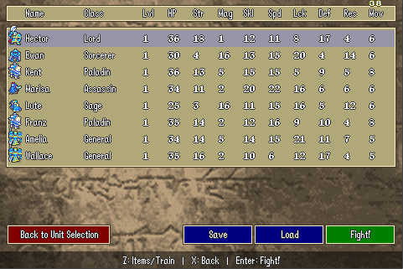

**Selecting a Unit (Z):** Selecting a unit (by moving the cursor over it and press Z) will take you to the training and equipping screen.

**Back to Unit Selection (X):** Selecting “Back to Unit Selection” or pressing X will take you back the unit selection screen. If you are in draft mode, you will not be able to do this.

**Save:** You can save the team you’ve built for future battles by selecting “Save”, then entering a name for your team. Record this team name somewhere, as you will need it to load up your team.  *Note: If you came to the team builder from the Connection Screen, you will have to save your team and load it again after you join the game.*

**Load:** Load a previously built team by selecting “Load” and entering the name of your team. If you don’t remember the name of the team (shame on you) you can find the names of all the saved teams in the “teams” folder (found in the same directory as FEServer.jar and Fire Emblem Multiplayer.jar). There will also be sample teams in the “teams” folder. If you are in draft mode, you will not be able to do this.

**Fight! (Enter):** Once your team is all properly trained and ready for combat, select Fight or press enter to start the game!  
*Note: If you came from the team builder, the button will be labeled “Exit” and will take you back to the Connection Screen.*

#### Selecting Units (All Pick Mode)

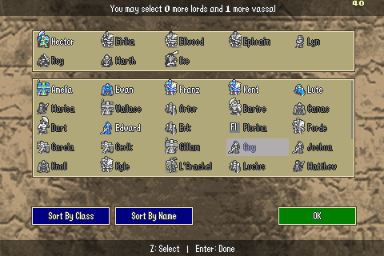

**Lords and Vassals:** Lord characters (main characters from the Fire Emblem games) will be shown in the top part of the screen. Normally you must bring exactly one lord unit. Lords start with their signature weapon (such as Falchion for Marth, Durandal for Eliwood). Non-lord characters are referred to as “vassals” and you may select as many as you like (up to the maximum number of units).

**Selecting Units (Z):** Hover over a unit with the cursor and press Z to select/deselect the unit. Deselecting a unit will recover any EXP or gold you have invested in the unit.



**Sort:** Select sort to sort the list of vassals by class or by name. This allows you to easily find the units you want.

**OK (Enter):** When you have finished selecting your units, select “OK” or press enter. This will take you back the Unit Summary screen.

#### Draft Mode

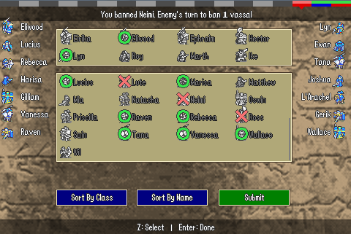

In Draft Mode, players alternate choosing units from the available units. In addition, you can ban units from being selected. Follow the on screen prompts to select and ban units.

**Choosing Units:** When prompted to, select a unit and press submit. When you choose a unit, a green circle will appear over it and it cannot be chosen again.

**Banning Units:** When prompted to, select a unit to ban and press submit. When you ban a unit, a red X will appear over it and it cannot be chosen by either player.

**Sort:** Select sort to sort the list of vassals by class or by name. This allows you to easily find the units you want.

When the draft phase is complete, you will be brought to the Unit Summary screen. You will not be able to go back to the unit selection screen.

#### Training and Equipping Units

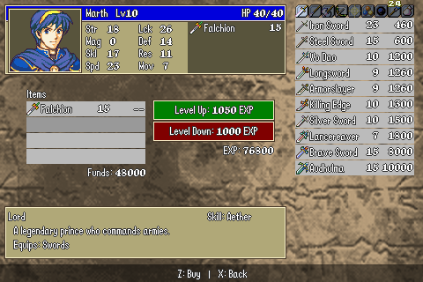

**Training:** Move the cursor to “Level Up” or “Level Down” and select. Leveling up will increase your unit’s stats and will cost a certain amount of experience. Leveling down will recover the amount of experience displayed.

**Buying Items**: Move the cursor over an empty inventory slot and select. You can then use the arrow keys to navigate through the shop and select the item you wish to buy. Press X to cancel out of the shop. Item information will be displayed in the info box at the bottom left.

**Selling Items:** Move the cursor over an item in your inventory and select. You will recover the total cost of the item.

**Back (X):** Press X to return to the unit summary screen.

## Battle

Battles are carried out in the same fashion as normal Fire Emblem games, but keep in mind you are fighting a living, thinking, human being, and not some dumb AI. Have fun!